**WeatherPy**

By Vivianti Santosa

The three weather pattern that we observed from this exercise are as follow :

* MAXIMUM TEMPERATURE  
  The areas that are closer to the polar - both South Pole and North Pole, as indicated by the bigger number (both positive and negative) number of latitudes - are colder areas, even at their hottest months (max temperature). While the areas that are closer to the Equator.are generally warmer.

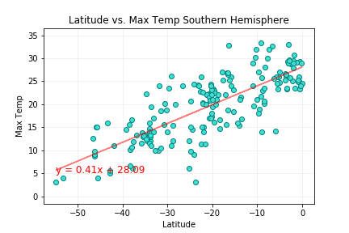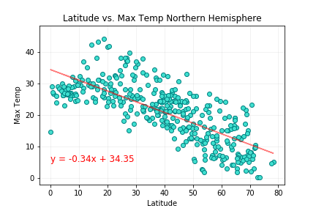

* HUMIDITY

While high humidity happened in areas of various latitude, low humidity or extreme dryness only happened in certain areas that are within the latitude of 20 to 40 degrees, with lower humidity happens in areas between latitude 15 to 45.

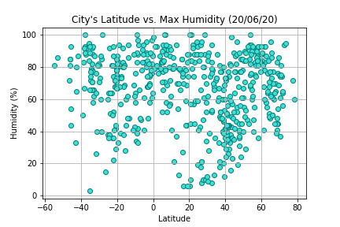

* CLOUDS and WINDS

We can see from the charts below that the level of cloudiness and winds speed does not depend on the areas’ latitudes.

The level of cloudiness is relatively not affected by the latitude at all and there are various levels of cloudiness for each latitude.

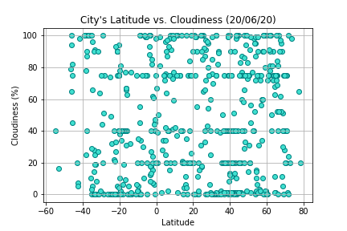

Extreme strong (high speed) wind, while happened in various latitude areas, happened much less often than areas of lower wind speed.

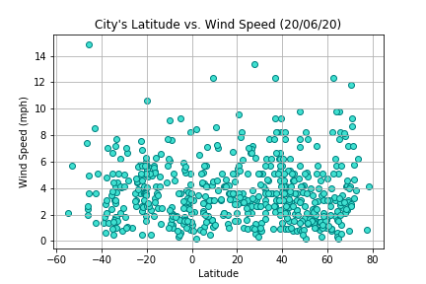

**VacationPy**

